MPT Gaming: Maria, Peter, and Tom

MPT Gaming Crossword Generator Documentation

Thank you for your interest in using the MPT Gaming Crossword generator. This software is written in php, and is run from the internet.

Table of Contents:

1. Introduction
2. Creating a user
3. Logging in to the system
4. The messaging system
5. Bring on the game

Introduction

The MPT Gaming crossword Generator is internet based software used to allow players from all over to solve randomly created crossword puzzles. All of the software is self contained on the internet, which also allows for a social networking aspect. When using this game, users can register, send messages to and receive messages from other users of our game, and can solve randomly generated puzzles.

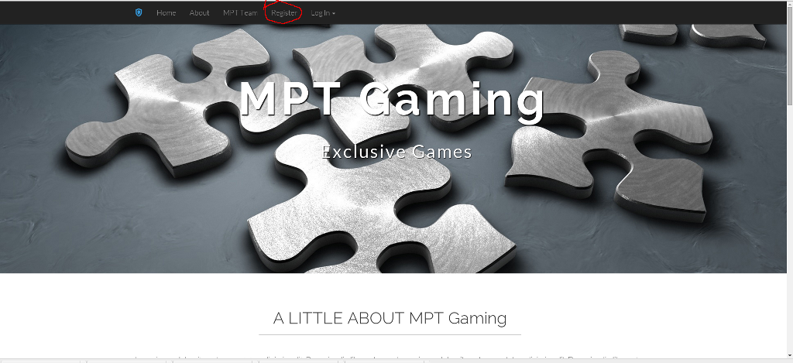

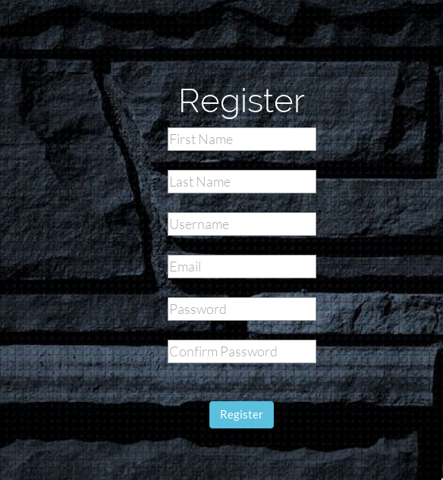

Creating a user

The first step in getting involved with the game is to register with our server. This can be done easily, by clicking on the register link on the application nav-bar. After clicking on this button, the user is brought to a registration form, where they can enter their name, user name, email address, and password of choice. Once the user has entered this information, they submit the information to the server, after which, they are registered and can sign in.

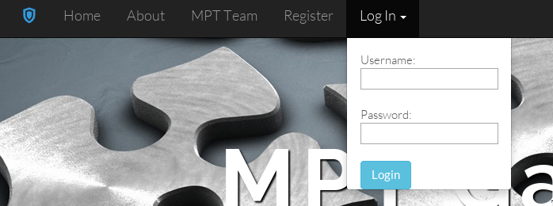

Signing in

The next step to getting involved with this growing community is to log into the site. Clicking on the log in button on the nav-bar will bring up a log-in frame. Enter in your user name and password and hit the Login button. After this, you will be logged in, and the log in button will be replaced with a button with your name. This becomes a new menu, where you can get to your account page, or log out. Clicking on the account page will bring you to the messaging system.

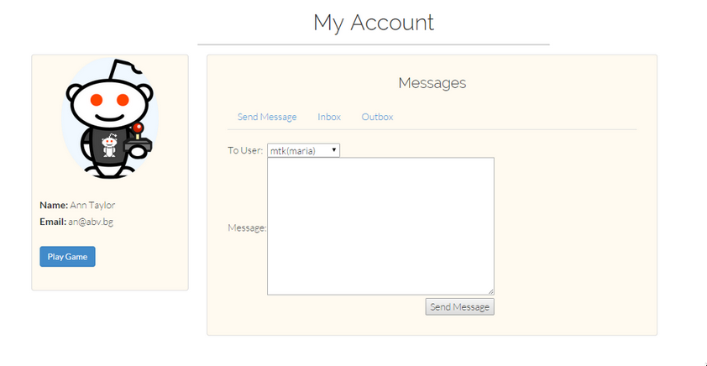

The messaging system

The messaging software is a simple email-like system that the user can use to pass messages on to other users of the website. There is a send message section, an inbox, and an outbox. To send a message, the user just selects the name of the user they wish to message from the dropdown box, and then enters the message in the message box. After the message has been entered, they just click on the send message button, and the message is sent to the user. The inbox is used to see the messages received, and also allows for deleting the received messages. The outbox displays the sent messages, and allows for their deletion.

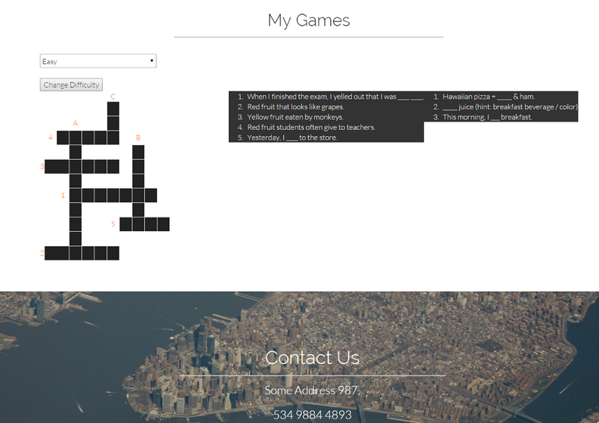

Bring on the Game

After clicking on the play game button on the my account page, this is the page that the user is presented. The user can select between 3 difficulty levels. This determines the grid that the users play on. The user looks at the clues and as the user enters letters, the cursor automatically advances to the next box.

That is it for the instructions on how to use the site. Thank you for reading and we hope that you enjoy the product that we have provided. –MPT Gaming.